Makalenizin başlığını buraya yazın

İlk Yazar Adı Soyadıa, İkinci Yazar Adı Soyadıb*, Üçüncü Yazar Adı Soyadıa,b

*a İlk Bağlı Bulunulan Kurum Adı, Bağlı Bulunulan Bölüm Adı, Adres (Şehir, Ülke), e-mail adresi*

*b İkinci Bağlı Bulunulan Kurum Adı, Bağlı Bulunulan Bölüm Adı, Adres (Şehir, Ülke), e-mail adresi (*Sorumlu Yazar)*

*c Üçüncü Bağlı Bulunulan Kurum Adı, Bağlı Bulunulan Bölüm Adı, Adres (Şehir, Ülke), e-mail adresi*

Özet

Özeti buraya yazınız. Özet tek paragraf olarak yazılmalı ve 250-400 kelime arasında olmalıdır. Özet, belirtilen kısaltmaları tanımlamalı, kaynak alıntılarından kaçınmalı ve tablo veya şekil ifadelerini içermemelidir.

***Anahtar Kelimeler:*** Anahtar Kelime 1; Anahtar Kelime 2; Anahtar Kelime 3; Anahtar Kelime 4; Anahtar Kelime 5. (Anahtar kelimeler en fazla 5 kelime olabilir.)

Type the title of your paper here

First Authora, Second Authorb*, Third Authora,b

a First Affiliated Institution Name, Affiliated Department Name, Address (City, Country) e-mail:firstauthor@zzz.com

b Second Affiliated Institution Name, Affiliated Department Name, Address (City, Country) e-mail:secondauthor@zzz.com (*Corresponding Author)

c Third Affiliated Institution Name, Affiliated Department Name, Address (City, Country) e-mail:secondauthor@zzz.com

Abstract

Write abstract here. Abstract should be written as one paragraph and should be between 250-400 words. Abstract should define abbreviations mentioned, avoid reference citations, and not include table or figure mentions.

***Keywords:*** Keyword1; Keyword2; Keyword3; Keyword4; Keyword5. (Keywords can be up to 5 words.)

1. INTRODUCTION

This document is a template for Microsoft Word versions 6.0 or later. Sent files must be in Microsoft Word only and should be formatted for direct printing. If you are reading a paper or PDF version of this document, please download the Microsoft Word versions, so you can use it to prepare your manuscript. You may use this Microsoft Word file as a template for Abstract, Keywords, Headlines, Figures, Tables, Equations, References and all other necessary information to arrange your manuscript for IJONFEST. Please make sure that you use as much as possible normal fonts in your documents. Special fonts, such as fonts used in the Far East (Japanese, Chinese, Korean, etc.) may cause problems during processing. Papers should be prepared in single column format suitable for direct printing onto paper with trim size 192 × 262 mm.

Section headings should be left justified, bold, with the first letter capitalized and numbered consecutively, starting with the Introduction.

1. SECOND HEADLINE
   1. *Second Headline 1*

Sub-section headings should be in capital and lower-case italic letters, numbered 1.1, 1.2, etc, and left justified, with second and subsequent lines indented. All headings should have a minimum of two text lines after them before a page or column break. Ensure the text area is not blank except for the last page.Please copy and paste your text here for the second Headline 1 section.

Lorem ipsum dolori sit amet, consetetur sadipscing elitr, sed diam nonumy eirmod tempor invidunt ut labore eyt dolore magna aliquyam erat, sed diam voluptua. At vero ehos et accusam et justo duo dolores et ea rebum. Stet clita kasd gub rgren, no sea takimata sanoctus egst Lorem ipsum dolor sit amet, consetetur sadipscing elitr; sed diam nonumy eirmod tempor invidunt ut lab ore sit emt dolore magna.

Lorem ipsum dolori sit amet, consetetur sadipscing elitr, sed diam nonumy eirmod tempor invidunt ut labore eyt dolore magna aliquyam erat, sed diam voluptua. At vero ehos et accusam et justo duo dolores et ea rebum. Stet clita kasd gub rgren, no sea takimata sanoctus egst Lorem ipsum dolor sit amet, consetetur sadipscing elitr; sed diam nonumy eirmod tempor invidunt ut lab ore sit emt dolore magna. Lorem ipsum dolori sit amet, consetetur sadipscing elitr, sed diam nonumy eirmod tempor invidunt ut labore eyt dolore magna aliquyam erat, sed diam voluptua. At vero ehos et accusam et justo duo dolores et ea rebum. Stet clita kasd gub rgren, no sea takimata sanoctus egst Lorem ipsum dolor sit amet, consetetur sadipscing elitr; sed diam nonumy eirmod tempor invidunt ut lab ore sit emt dolore magna.

* 1. *Second Headline 2*

Please copy and paste your text here for the second Headline 2 section. Lorem ipsum dolori sit amet, consetetur sadipscing elitr, sed diam nonumy eirmod tempor invidunt ut labore eyt dolore magna aliquyam erat, sed diam voluptua. At vero ehos et accusam et justo duo dolores et ea rebum. Stet clita kasd gub rgren, no sea takimata sanoctus egst Lorem ipsum dolor sit amet, consetetur sadipscing elitr; sed diam nonumy eirmod tempor invidunt ut lab ore sit emt dolore magna.

Lorem ipsum dolori sit amet, consetetur sadipscing elitr, sed diam nonumy eirmod tempor invidunt ut labore eyt dolore magna aliquyam erat, sed diam voluptua. At vero ehos et accusam et justo duo dolores et ea rebum. Stet clita kasd gub rgren, no sea takimata sanoctus egst Lorem ipsum dolor sit amet, consetetur sadipscing elitr; sed diam nonumy eirmod tempor invidunt ut lab ore sit emt dolore magna. Lorem ipsum dolori sit amet, consetetur sadipscing elitr, sed diam nonumy eirmod tempor invidunt ut labore eyt dolore magna aliquyam erat, sed diam voluptua. At vero ehos et accusam et justo duo dolores et ea rebum. Stet clita kasd gub rgren, no sea takimata sanoctus egst Lorem ipsum dolor sit amet, consetetur sadipscing elitr; sed diam nonumy eirmod tempor invidunt ut lab ore sit emt dolore magna.

* + 1. *Figures*

Ensure that each illustration has a caption. Supply captions separately, not attached to the figure. A caption should comprise a brief title (not on the figure itself) and a description of the illustration. Keep text in the illustrations themselves to a minimum but explain all symbols and abbreviations used. Ensure all figure citations in the text match the files provided. All figures should be numbered with Arabic numerals (1, 2, 3,….).

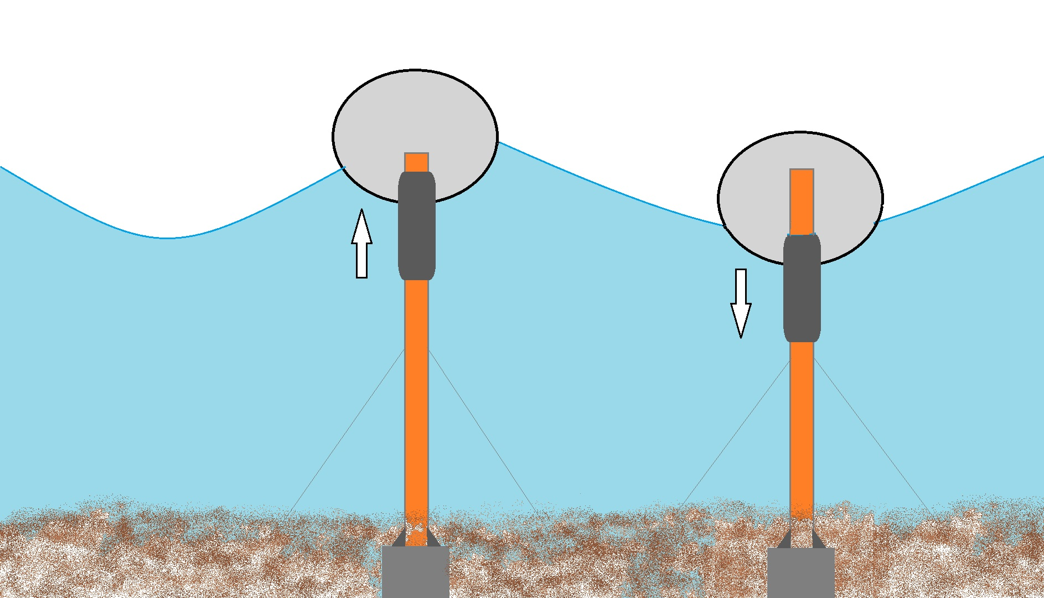

**Figure 1.** An example of a figure.

* + 1. *Tables*

Ensure that all tables have their own captions. A caption should comprise a brief title and a description, which should be placed above tables, left justified. Keep the text in the tables to a minimum, but all symbols and abbreviations used should be explained. Please submit tables as editable text and not as images. Tables must be placed next to the relevant text in the article. Number tables consecutively in accordance with their appearance in the text. Be sparing in the use of tables and ensure that the data presented in them do not duplicate results described elsewhere in the article. Please avoid using vertical rules. Ensure all table citations in the text match the files provided.

**Table 1.** An example of a table.

|  |  |  |
| --- | --- | --- |
| **An example of a column heading** | **Column A (*m*)** | **Column B (*m*)** |
| Criterion 1 | 1 | 2 |
| Criterion 2 | 3 | 4 |
| Criterion 3 | 5 | 6 |

* + 1. *Equations*

Equations and formulae should be typed as editable text and be in Mathtype, and numbered consecutively with Arabic numerals in parentheses on the right hand side of the page (if referred to explicitly in the text). They should also be separated from the surrounding text by one space. Present simple formulae in line with normal text where possible and use the solidus (/) instead of a horizontal line for small fractional terms, e.g., X/Y. In principle, variables are to be presented in italics.

** (1)

* + 1. *Construction of references*

References must be listed at the end of the paper. Do not begin them on a new page unless this is absolutely necessary. Authors should ensure that every reference in the text appears in the list of references and vice versa. Indicate references by [1] or [2,3] in the text.

* + 1. *Footnotes*

Footnotes should be avoided if possible. Necessary footnotes should be denoted in the text by consecutive superscript letters[1]1. The footnotes should be typed single spaced, and in smaller type size (8 pt), at the foot of the page in which they are mentioned, and separated from the main text by a one line space extending at the foot of the column. The Els-footnote style is available in the MS Word for the text of the footnote.

Acknowledgements

Acknowledgements and Reference heading should be without numbers and left justified, bold and with the first letter capitalized.

**Funding**

The authors should declare the financial interests which may be considered as potential competing interests.

**Declaration of Competing Interest**

Competing interest statement declared by authors. This statement must also appear in your manuscript before the references.

1. An example appendix

Authors can provide an appendix section before References section, without number. Multiple appendices should all have headings in the style used above. They will automatically be ordered A, B, C, etc.

* 1. Sub-heading within an appendix

The authors can add subheadings within the Appendix if needed.

References

[1] Surname1 D, Surname2 K. *Guide lines book for authors*. 2nd ed. İGÜN: IJONFEST; 2011.

[2] Surname1, F., Surname2, G., Surname3, A., 2023. How to prepare a paper: Guide for authors. International Journal of New Findings in Engineering, Science And Technology (IJONFEST), 191, 202.

1. 1 Footnote text1.

   2 Footnote text2.